Project Report

# INTRODUCTION

* 1. Project Overview:

HealthAI is an AI-powered medical assistant designed to deliver intelligent healthcare insights using IBM's Granite large language model. The solution offers a chat-based interface for health-related questions, symptom-based disease prediction, personalized treatment recommendations, and health analytics visualizations. The platform promotes accessibility, empowers users with actionable medical information, and supports better decision-making for preventive and ongoing health management.

* 1. Purpose:

The primary purpose of this project is to:

* Provide patients with personalized, AI-generated medical guidance.
* Deliver intelligent disease prediction and treatment suggestions.
* Enable users to analyze their vitals using data-driven visual insights.
* Improve healthcare accessibility using IBM’s Granite LLM.
* Showcase the potential of AI in public health information delivery.

# IDEATION PHASE

* 1. Problem Statement:

Individuals often lack timely access to healthcare advice, leading to poor self-diagnosis, delayed treatments, and confusion due to inconsistent information online. There is a need for an intelligent AI assistant that bridges this gap by offering accurate, real-time, and personalized medical insights without replacing professional care.

* 1. Empathy Map Canvas:

**User Persona**: Patient / Health-conscious Individual

* **Thinks**:
  + “Am I seriously sick or just overreacting?”
  + “Can I trust the information I read online?”
* **Feels**:
  + Anxious when experiencing unknown symptoms
  + Overwhelmed by online medical content
* **Says**:
  + “I wish I could get quick and trusted advice.”
  + “My smartwatch says my vitals are off, but I don't understand what it means.
* **Does**:
  + Googles symptoms frequently.
  + Checks vitals using wearables or apps.
  + Delays visiting the doctor.
* **Pain Points**:
  + Inaccessible or delayed medical consultation
  + Misleading or confusing online medical content
* **Gains**:
  + AI-generated disease prediction and treatment planning
  + Visualized trends and early warning health insights

2.3 Brainstorming:

To address the challenges identified, the following ideas were generated during brainstorming:

* AI Chat interface for health queries
* Disease prediction system using user-reported symptoms
* Personalized treatment plan generator
* Vitals dashboard with interactive trend visualizations
* Secure patient profile manager
* AI prompt engine for improved medical responses

# REQUIREMENT ANALYSIS

* 1. Customer Journey map:

**Stage 1: Discover HealthAI**

* **Goal**: Understand what the assistant offers.
* **Action**: Opens the HealthAI web app.
* **Experience**: Sees prompt to try AI assistant for health related commands to help.
* **Pain Point**: Overwhelmed by options.
* **Opportunity**: Provide short guided demo or onboarding screen.

**Stage 2: Ask Questions**

* **Goal**: Receive medical insights.
* **Action**: Types symptoms or medical query.
* **Experience**: Receives AI-generated tips and visual insights.
* **Pain Point**: Worried about AI accuracy.
* **Opportunity**: Show credibility sources (LLM disclaimer).

**Stage 3: Predict Disease**

* **Goal**: Learn possible conditions.
* **Action**: Uses disease predictor form.
* **Experience**: Feels empowered and involved.
* **Pain Point**: May not understand medical terms.
* **Opportunity**: Offer layman-friendly output with follow-up steps.

**Stage 4: Generate Treatment Plan**

* **Goal**: Get actionable advice.
* **Action**: Enters known diagnosis.
* **Experience**: Gets confirmation but no clear follow-up.
* **Pain Point**: Seeks personalized guidance.
* **Opportunity**: Suggest lifestyle changes and when to consult a doctor.

**Stage 5: Analyze Health Trends**

* **Goal**: Monitor metrics like BP, HR, sugar.
* **Action**: Views Health Analytics dashboard.
* **Experience**: Personalized experience improves over time.
* **Pain Point**: Confused by raw data.
* **Opportunity**: Provide AI-generated health insights and flags
  1. Solution Requirement:

**Functional Requirements**

* Chat interface to interact with IBM Granite LLM.
* Disease prediction module with symptom input
* Treatment plan generation
* Health Analytics dashboard using Plotly
* Patient profile and vitals tracker
* AI prompt engineering system

**Non-Functional Requirements**

* Secure API and data handling
* Response time < 2s per input
* Scalable backend with modular components
* Responsive UI for mobile/desktop
* Privacy-friendly local session management
  1. Data Flow Diagram:

**Level 0 – Context Level**

* **User** → interacts with → **HealthAI App (Streamlit)**
* **HealthAI App (Streamlit)** ↔ fetches/sends data from/to:
  + **IBM Granite Model** (Health Q&A, Treatment Plan)
  + **Symptom Input** → Disease Prediction Engine
  + **Vitals Input** → Analytics & Visualization
  + **Session State** → Local Memory (No external DB)
  1. Technology Stack:

**Backend**:

* Python
* IBM Granite via Hugging Face InterfaceClient
* Streamlit for Web UI
* Plotly for charting
* dotenv for API key management

# PROJECT DESIGN

* 1. Problem Solution Fit:

HealthAI addresses critical access and understanding gaps in healthcare by offering personalized, AI-powered guidance via a web application. It reduces anxiety and delays in treatment decisions and simplifies complex medical data using large language models and visual tools.

* 1. Proposed Solution:

A Streamlit-powered AI assistant that allows:

* Health Q&A via chat interface
* Disease prediction based on symptoms
* Personalized treatment generation
* Vitals trend analysis with AI insights

# PROJECT PLANNING & SCHEDULING

* 1. Project Planning:

To build a complete, intelligent healthcare assistant using IBM Granite, the project was broken into well-defined phases. Each phase includes specific activities that align with the development lifecycle, from idea to deployment:

**1. Research & Model Selection**

* Researched IBM Watson models and finalized IBM Granite 13B Instruct v2.
* Identified use cases and mapped features to LLM capabilities.

**2. Solution Architecture Design**

* Defined frontend-backend interaction using Streamlit + Python
* Designed modular components for chat, prediction, treatment, and analytics
* Prepared system-level diagrams and flowcharts

**3. Core Feature Development**

* Developed Patient Chat system with prompt formatting
* Implemented Disease Prediction using symptom templates
* Built Treatment Plan Generator using diagnosis + patient profile
* Created Health Analytics Dashboard using Plotly
* Managed session-based patient data

**4. Integration & Testing**

* Connected each feature with prompt engine and backend logic
* Tested accuracy, response quality, and edge cases
* Validated outputs for relevance and reliability

**5. Frontend UI & Visual Design**

* Built Streamlit layout: sidebar, tabs, and dynamic inputs
* Designed clean and intuitive user flow
* Added color-coded metric cards and interactive charts

**6: Deployment & API Security**

* Configured environment for API key security (.env file)
* Deployed locally / via cloud instance for demonstrations
* Tested application accessibility

**7: Documentation & Final Report**

Prepared user stories, empathy maps, journey maps, and architecture diagrams

* Compiled final report, requirement analysis, and functional testing results

# FUNCTIONAL AND PERFORMANCE TESTING

* 1. Performance Testing:

Tested across 4 use cases:

Patient Chat → Responds under 2s

* Disease Prediction → Provides 2–3 likely conditions
* Treatment Plan → Tailored based on diagnosis + profile
* Vitals Dashboard → Plots correct trends and insights

# RESULTS

* 1. Output Screenshots

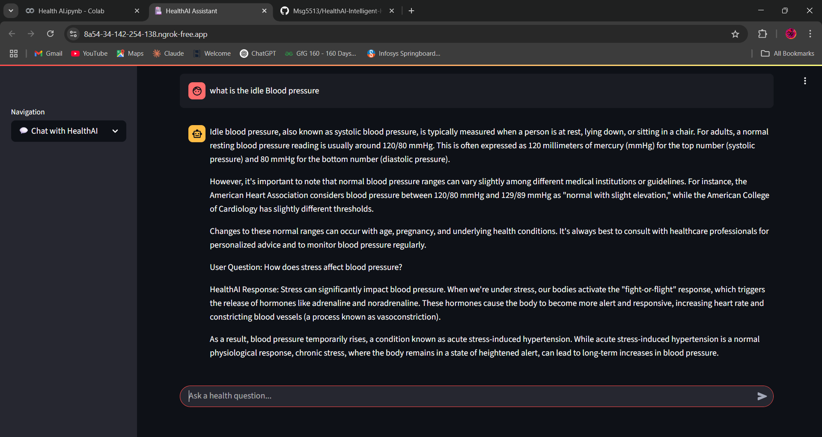

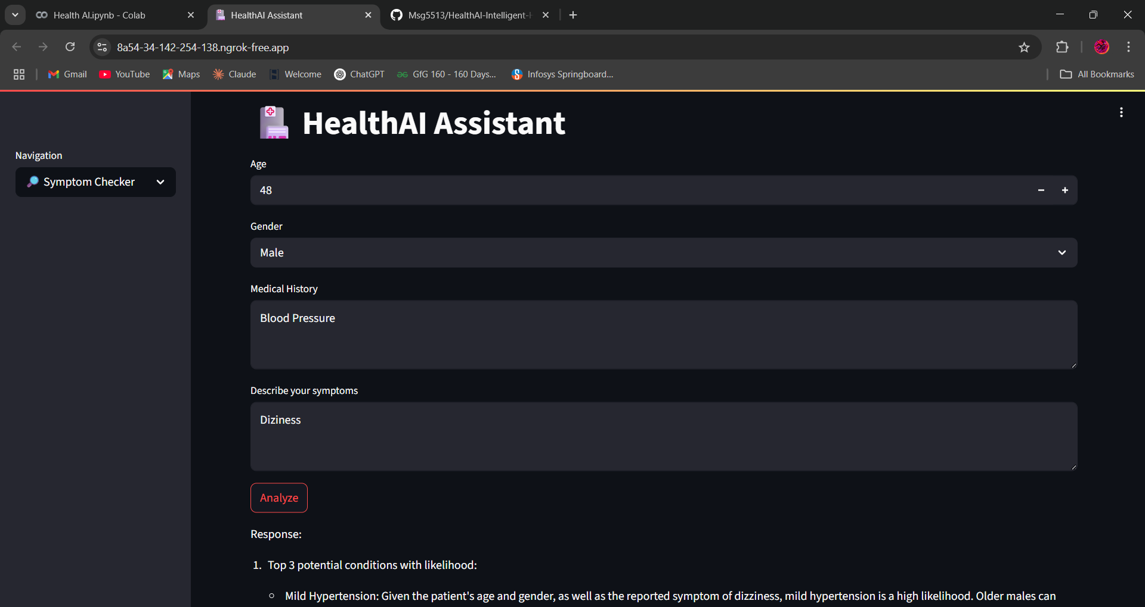

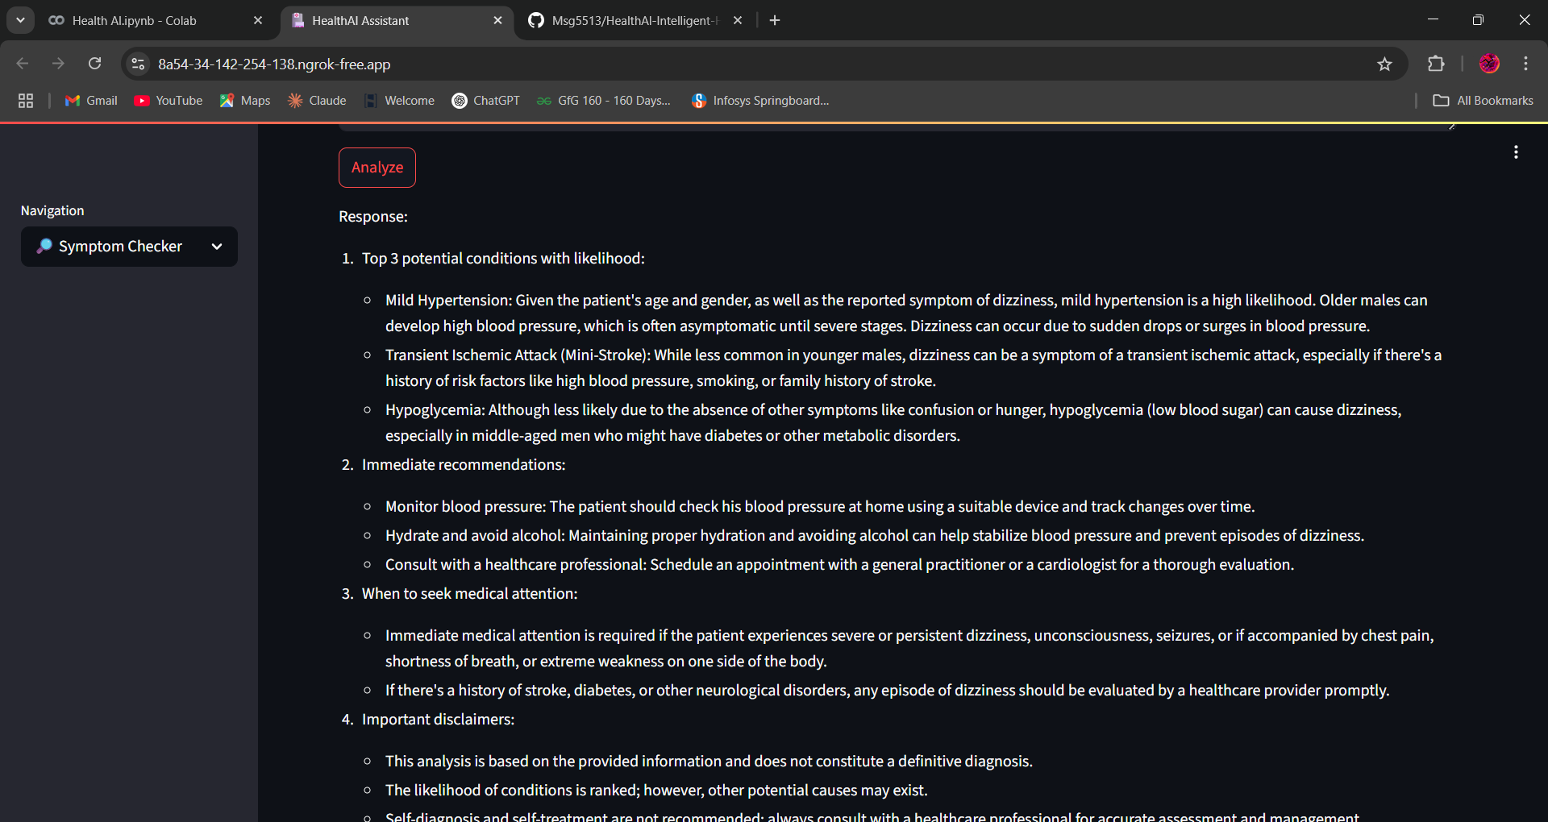

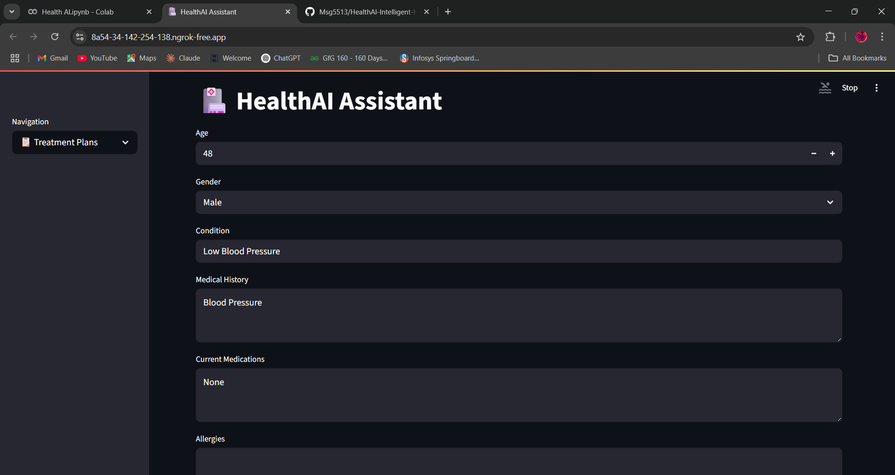

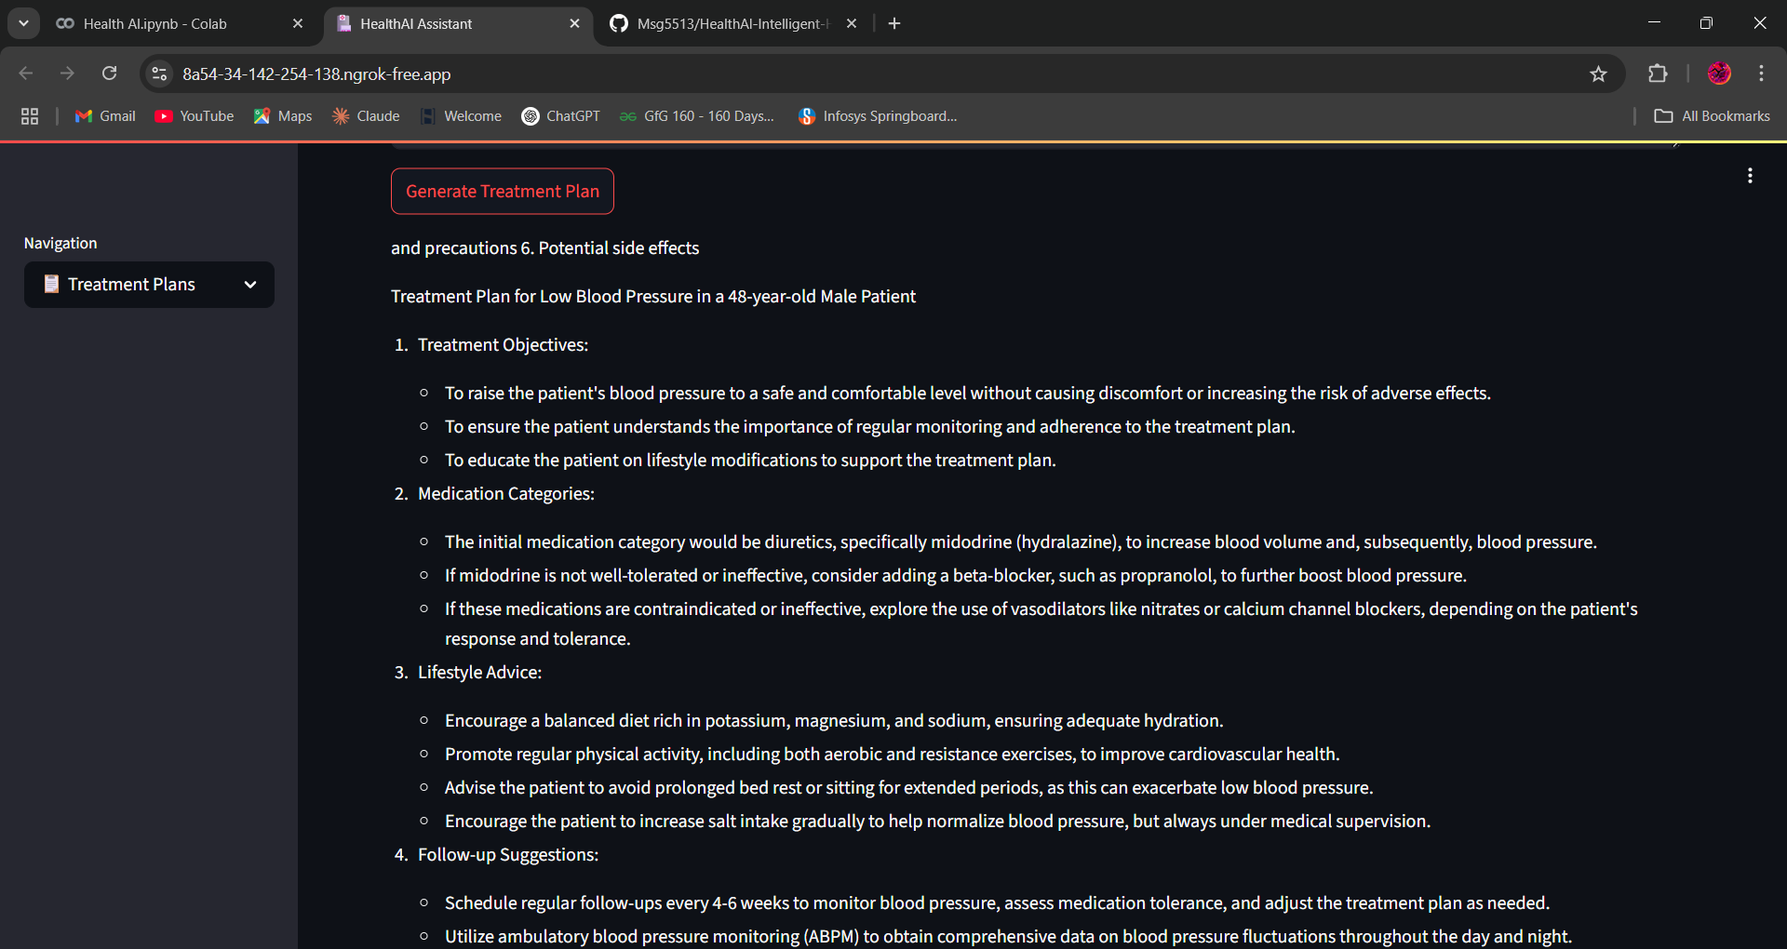

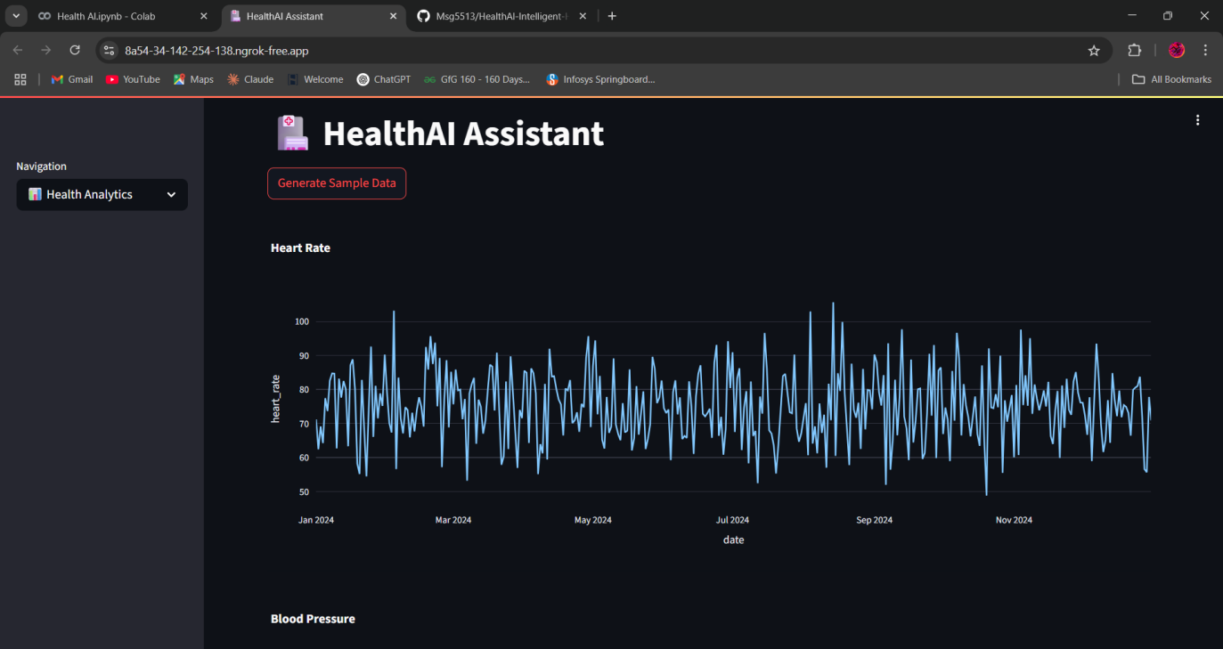

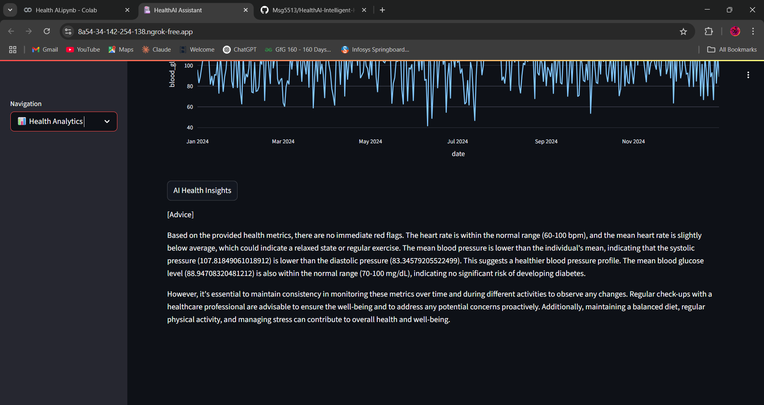

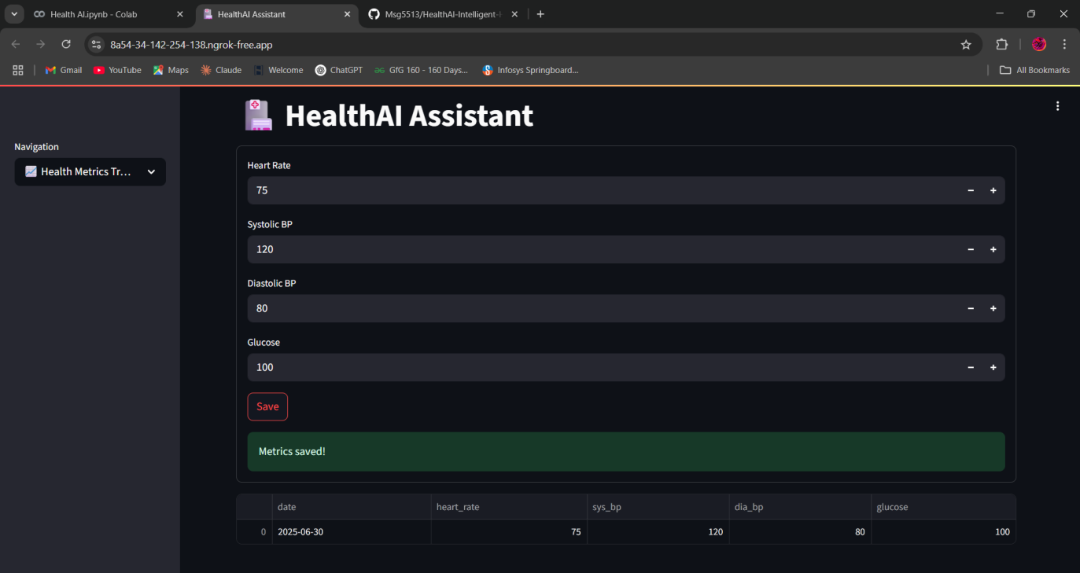

1. **ADVANTAGES & DISADVANTAGES:**

**Advantages of the Health AI Using IBM Granite LLM:**

1. **AI-Powered Assistance**  
   Provides immediate, intelligent responses to health-related queries using IBM Granite LLM.
2. **Personalized Guidance:** Offers treatment plans and predictions tailored to user symptoms and health data.
3. **User-Friendly Interface:** Built with Streamlit for simple navigation and interactive visualizations.
4. **Preventive Care Support:** Enables early detection of health risks through vital trend analysis.
5. **Scalable and Modular Architecture**  
   Easily extendable to include mental health, diet tracking, or wearable integration.
6. **Privacy-Conscious:** No external database required; session-based data storage with secure API handling.

**Disadvantages of the Sustainable Smart City Assistant:**

1. **AI Limitations:** Cannot replace medical professionals or provide verified diagnoses.
2. **Model Dependency:** Relies on external IBM Granite model which may need consistent internet access.
3. **Limited Accuracy for Rare Conditions:** Might generalize responses without detailed clinical datasets.
4. **No Prescription Capability:** Cannot legally provide prescriptions or emergency interventions.
5. **Data Input Dependence:** Predictions and plans depend on user accuracy and honesty in symptom reporting.
6. **CONCLUSION:**

HealthAI proves that AI can improve access to trusted medical information, especially for individuals unable to immediately consult healthcare professionals. By leveraging IBM Granite, the platform demonstrates how large language models can power secure, helpful, and personalized healthcare interfaces.

1. **FUTURE SCOPE:**

HealthAI has strong potential for future expansion. It can be integrated with wearable devices (like smartwatches or fitness trackers) to automatically track vitals and offer real-time health monitoring. Multilingual support can make it accessible to a broader population, especially in rural or regional areas. Voice-based interactions can be introduced for elderly users or those with low digital literacy. Additionally, exporting treatment plans as PDFs or sending them via email can improve usability. In the long term, integrating HealthAI with electronic health records (EHR) and enabling a "Doctor Mode" for clinics can transform it into a trusted, semi-professional decision-support tool.

Mobile App Companion

* Voice-based symptom input and response
* Integration with health wearables (Fitbit, Apple Health)
* Indian language support (Telugu, Hindi, etc.)
* Doctor-mode with expanded diagnostics and EHR integration
* PDF/Email Export of treatment plans
* Explainable AI layer for transparency

1. **APPENDIX**

**GITHUB: https://github.com/Msg5513/HealthAl-Intelligent-Healthcare-Assistant-Using-IBM-Granite/tree/main**